BEEE Lab Evaluation

Aim : Design a system that automatically rings a bell for 2 ms whenever someone enters a temple, assuming only one person can enter at a time.

Theory :

Concept : We have used an ultrasonic and a buzzer in order to complete this project to make the bell ring automatically whenever someone enter inside the temple. The ultrasonic will help in detecting the presence of any person entering the temple and buzzer will help in ringing.

Learning and Observation : I learned that through this project we can count the total number of visitors entering the temple daily which can be used as a further record.

Circuit diagram :

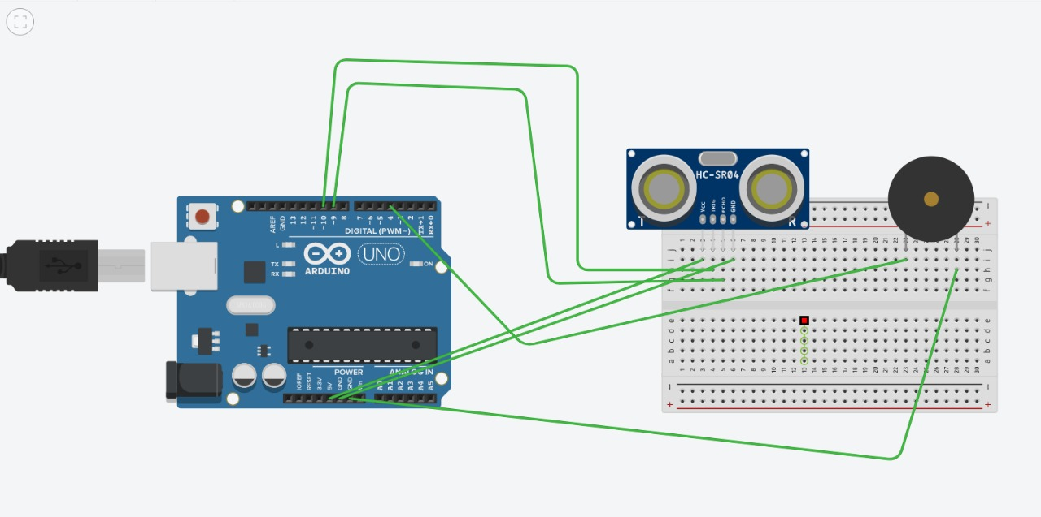

Coding :

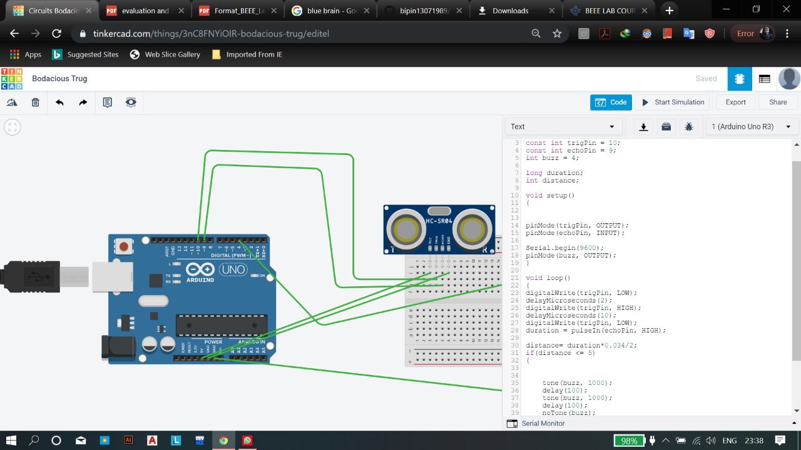

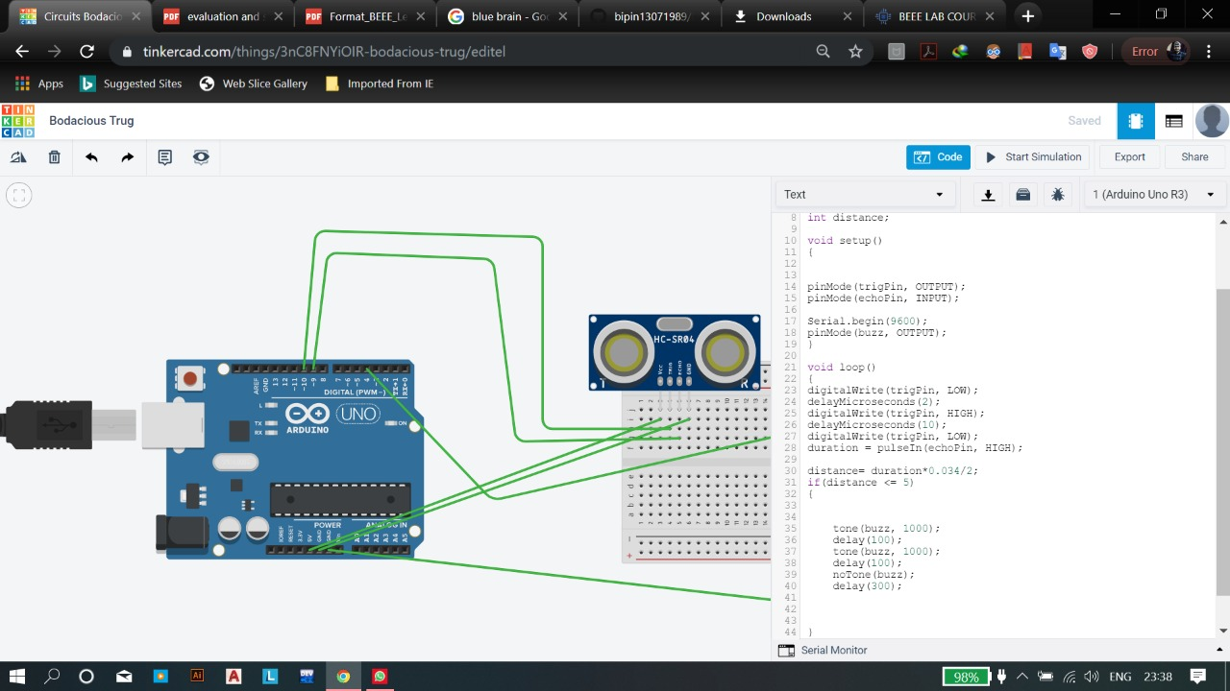

Precautions

* The connections should be intact and properly covered as a large number of people will be entering the temple who are unknown of the project
* Connections should be clean and neat

Learning Outcomes

We learned a new concept related to ultrasonic and buzzer which can definitely be further used for various other projects and assignments too and thus it is proved very helpful!